
Getting Started with Software Testing | Chapter 1

While developing an application, developers tend to make certain mistakes that are not easily identified by them. Post development, if an application is directly deployed at the actual server without being tested, it can lead to severe issues, such as system breakdown, customer dissatisfaction, or legal problems.
However, if the application is thoroughly tested before being deployed at the production environment, then these issues can be easily avoided. Software testing plays a vital role in development of a bug-free application and helps in delivering a defect-free product.
This chapter introduces the concept of software testing along with the software-testing life cycle. In addition, it discusses different types of testing and identifies JUnit as a unit testing tool.
Objectives
In this chapter, you will learn to:
- Identify software testing
- Identify unit testing


Introducing Software Testing
Consider a scenario of a bank application. This application has different modules, such as user account management, money transfer management, and loan management. Your organization needs to develop this application. The development team develops the application and directly deploys the same to the production environment. However, the customers of the bank encounter an error in the money transfer module of the application wherein the money got deducted from the payer’s account, but was not credited to the payee’s account. This incident spoils the goodwill of the bank and creates dissatisfaction among its customers. Therefore, to avoid such situations, a software application should be thoroughly tested before it is deployed to the live environment.
Software testing plays a vital role in the development of defect-free software. Software should be tested at the developer’s end to identify all the errors and issues in the code, so that there are no leakages of errors to the production environment. To test software comprehensively, a software testing life cycle is devised. It serves as a general guideline for testing an application and can vary according to the testing strategy being used. For example, in the case of the bank application, you can develop the tests either before or after the application is developed. These are two different testing approaches wherein you first develop the code and then test it or you first develop the test cases by understanding and analyzing the scenario and then develop the code according to the test cases.
Testing strategy refers to the type of testing approach being used. For example, you can test individual modules, two or more integrated modules, or the complete application.
Let us now understand the software testing life cycle.

Software Testing Life Cycle
Software Testing Life Cycle (STLC) is a systematic and progressive approach used for testing software to enhance its quality. The software should be tested with the intent of finding every possible bug introduced in the code during the software development. It helps in ensuring the delivery of quality software to users with the minimum risk of failure and errors.
STLC comprises the six phases, as shown in the following figure.
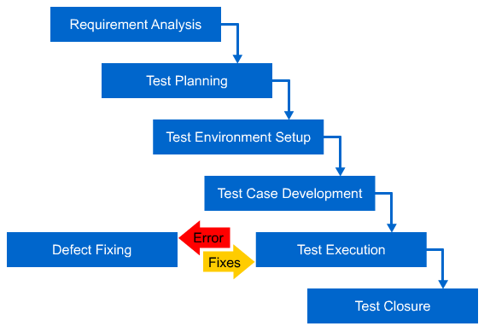
The Six Phases of STLC
STLC consists of the following six phases:
- Requirement analysis: This is the initial step of the testing process, which focuses on understanding the requirement that has been laid down in the requirement specification document. After understanding the requirements, you need to identify the elements of an application to be tested and can be tested. If you identify any requirement that is not testable, you can conduct sessions with the required people, such as stakeholders, to resolve the issue. This is the phase to reconsider any non-testable areas or requirements. Apart from identifying the testing elements, you may decide the types of testing that you will perform while testing the application.
- Test planning: Test planning is the most essential step of the testing process that emphasizes on achieving an optimum balance between the specified requirements and the available resources. It also defines the objectives of the testing. Further, you need to determine the required effort and allocate the determined responsibilities to the individuals. You need to prepare the schedule for the complete testing phase of the application. In addition, you need to identify the risks involved, if any, and convey the same to the stakeholders.
- Test environment setup: Setting up the test environment plays a vital role in the testing process. In this phase, you need to decide the hardware and software requirements, such as server, network, or software, needed to test the application. It includes setting up the necessary tools and infrastructure required for convenient and smooth execution of the tests.
- Test case development: During this phase of STLC, the emphasis is on developing the test. In this phase, you write step-by-step instructions for the test conditions that are identified in the initial stages of STLC. It is a good practice to create detailed test conditions based on which test cases can be identified easily. In addition, breaking test conditions into various sub-conditions ensures that the entire code is tested by the test cases and no area of code is left untested. In this phase, you also need to maintain a requirement-traceable metrics, which maps all the requirements specified with the test cases designed.
- Test execution: Once developed, the test cases are executed under the given test environment to verify the test results. The outcome of the test can be a successful or poor endeavor. When the outcome of a test results in failure, you need to fix the issue and retest it. Therefore, test execution phase has a small cycle that executes till the time all results are successful. This cycle involves test execution and defect fixes.
- Test closure: Once the test cases are successfully executed, you need to close the testing life cycle. It includes matching the expected results of the test cases with the desired objectives. In addition, you need to generate test reports specifying the issues identified, issues rectified, test results summary, and test metrics, such as timelines, quality, coverage, and cost. These test results or facts and figures should be reported to the concerned people, such as stakeholders.

Different Types of Testing
Software testing has become a diversified field constituting different types of testing strategies and levels. The testing strategy is the approach followed by you to test software. This strategy can be of the following types:
- Black box testing: This testing strategy tests the software for its overall functionality and does not test each statement and branches given in the code. In this type of testing, you are not given access to the source code because you check the software’s functionality in terms of input and the desired output only. You define a set of output for a respective set of input and verify if the actual output is same as the defined output. This type of testing is known as black box testing approach because the code is considered to be in a black box and, therefore, not visible. You can just verify the input and output passing though this black box.
- White box testing: In this testing strategy, testing is done in detail. Here, you need to understand the code and then test every statement and condition given in the code. While using this strategy, you design test cases such that the test executes all the branches and statement of the code and, therefore, you need to know the code in detail. This type of testing is also known as glass box testing because, in this case, the code is visible to you in a manner that it is kept in a transparent glass box.
Once the testing approach is decided, the testing can be done at various levels, which are:
- Unit testing: This type of testing tests the individual units of application, which can be a method of a class, a complete class, a set of inter-related class, or a module. Unit testing is one of the best development practices to test the smaller unit of code. It reduces the chances of encountering errors at a later stage of development and makes the code efficient. The sole objective of the unit testing is to individually perform tests on each unit of an application to ensure their functional efficiency individually.
For example, consider the scenario of the banking application. In order to develop a modularized application, the application was broken down into various modules, such as user account management, money transfer management, and loan management. These modules are independent and provide various facilities to the users, such as maintaining their data, helping them in transferring money from one account to another, and enabling them to get the loan from the bank. Therefore, these individual modules must be tested for their desired functionality.
- Integration testing: When the individual units are tested, they need to be integrated and then tested. This type of testing verifies that different units, when combined together, produce the desired result. Integration testing tests different modules of the given application while integration. This type of testing examines whether each module is working perfectly along with the other modules of the same application on integration.
For example, consider the scenario of the banking application. In this application, you defined three modules being developed individually. When any two modules of this application were ready, you could combine them together as one unit, which, in turn, could be combined to the third module. Now, integration testing aims at identifying the errors, if any, during the integration of the two modules. When two modules are inter-dependent, you may encounter certain errors on combining them into a single bigger module. Therefore, it helps in tracing the errors easily and rectifying them at an early stage of application development.
- System testing: It tests the complete system for the desired functionality. In the case of system testing, you need to combine all the units of an application to build the entire application. Then, this application is tested as a complete system to verify whether the application meets the requirements specified at the beginning of the development phase. System testing tests the reliability of the overall system. The system can be viewed as one unit that was requested by the customer. This level of testing generally uses black box testing approach because in this case, you test the complete functionality of the software by providing certain input and verifying the outcome of that input.
For example, consider the scenario of the banking application. In this application, the system includes three modules to be checked in an end-to-end manner for detecting errors. It will check how all the modules are able to interact with each other and behave as a system. It covers and tests every detailed input in the application from the user’s perspective to determine the probable behavior of the system.
- Regression testing: It refers to testing an application after it has been modified. This type of testing aims to find out bugs in the code after it has been changed. It also looks for the effect of the change in other parts of the code. Regression testing is to retest the given modules with same or different tests to ensure that changes in a module have not impacted other modules.
For example, consider the scenario of the banking application. With the three given modules of the application, suppose a defect hits the user account management module in which the user is unable to login to an account with the given user credentials. This defect is reported to the concerned organization. Once this defect is rectified, the other modules, such as money transfer and loan management, should be tested again to check whether the change in user account management module has affected these modules.
- Acceptance testing: As the name implies, acceptance testing refers to the testing done at the customer’s end for accepting the software. This type of testing verifies whether the developed application meets the user requirements. Acceptance testing is performed at the client-site in real-time environment. Once the system testing is performed successfully, then the proposed system is considered ready to be deployed at the client-side with all the tools and infrastructure present. The system should use the test data to verify whether it meets all the requirements specified by the customer. When the software is accepted by the user, it denotes the successful delivery of the software.
For example, consider the scenario of the banking application. At this stage, the entire flow of the application can be walked through by initiating the activity of opening a new account and then transferring money from one account to another. In addition, the user should be able to generate the request for loan, if he wants to avail the same. The walkthrough should display user-friendly messages, wherever required. All these functionalities and features should be seamlessly achieved for the client to appreciate the system.
- Performance testing: An application that performs all the tasks perfectly, but responds lately is considered to be inefficient, and users do not prefer using such applications. Therefore, it is essential to check the response time of the application in a usual scenario as well as in a loaded scenario. This type of testing is known as performance testing. Performance testing is to test the entire non-functional performance expected of the system. The non-functional requirement could be related with the precise time in which a Web page of a Web-based application should be opened. The non-functional parameters are not just restricted to time, but also to speed, security, reliability, and other performance-related issues of the application.
For example, consider the scenario of the banking application. The non-functional requirement specified in the requirement document beholds that the Web page of any module, which is being requested from the user, should open in less than five seconds. Therefore, it is necessary to test this application for various non-functional aspects of the application, which can be done with the help of performance testing.


Just a minute:
Which one of the following testing strategies tests the software for its overall functionality and does not test each statement and branches given in the code?
- Regression testing
- Black box testing
- White box testing
- Performance testing

Answer:
2. Black box testing

Introducing Unit Testing
Consider the scenario of the bank application development. Jenny has been assigned the task of developing the user account management module of the application. This module has multiple classes containing multiple methods. Jenny develops the methods and integrates these together in a class. When she validates the functionality of the class, it fails to generate the desired output. There are bugs in a few methods, which propagate to other methods as well. As a result, she needs to spend time and effort in tracing and rectifying the error. If these methods were tested before they were integrated together, the application development and debugging time could have been reduced. The testing of small pieces of code, known as units, is known as unit testing. This unit can be a piece of code, such as a method, multiple methods of a class, a class, multiple classes, or even small modules of an application. The unit testing should be done to ensure that the smallest unit of the code is bug-free and reusable.
Unit testing provides the following advantages:
- It ensures that the individual units are reliable and error-free, thereby simplifying the integration testing because if individual units are working as expected, then they are expected to work fine when integrated. For example, in the scenario of the bank application, the individual units developed were not unit tested. As a result, Jenny had to spend a lot of time and effort to rectify the error.
- It eases the maintenance of the software because the test designed for the original piece of code can be executed every time the code is modified. This enables you to verify whether the change has affected the original functionality.
- It finds the errors/issues in the code at the development stage, thereby reducing the impact and the cost that might be huge when it occurs at integration testing stage or later. For example, in the scenario of the bank application, Jenny did not perform the unit testing of the methods being developed. As a result, when she integrated these units together, she encountered an error that propagated to other methods as well. Therefore, Jenny had to spend a lot of time and effort to rectify the error, which impacted the cost of the project as well.
While developing applications, you might feel unit testing to be a tedious process. Moreover, you might think that your job is to develop the code and not to test it. However, unit test ensures that the code developed by you is error-free and meets the specified requirement of the application. Therefore, you should always perform unit testing of your code and ensure the quality of the code developed. Java provides the JUnit framework to test the Java code. To test Java code, you can use NetBeans or Eclipse IDE.

Exploring IDEs for Unit Testing
You can test the Java code using the JUnit framework at the command prompt as well as in IDE. However, to use the JUnit framework at command line, you need to perform the following steps:
- Verify if JDK is installed on your machine. If not, install JDK on your machine.
- Set the Java environment using the JAVA_HOME environment variable and add the Java compiler location to the Path system variable.
For example, set JAVA_HOME to C:\Program Files\Java\jdk1.7.0_25 and append the C:\Program Files\Java\jdk1.7.0_25\bin string to Path.
- Download and save the JUnit jar file in your disk.
- Set the JUnit environment variable and the CLASSPATH environment variable.
For example, if you have saved your JUnit jar file named junit4.10.jar to the JUNIT folder in the C drive, then set JUNIT_HOME to C:\JUNIT and the CLASSPATH variable to %CLASSPATH%;%JUNIT_HOME%\junit-4.11.jar;%JUNIT_HOME%\
hamcrest-core-1.3.jar;.;.
- Create the test file, which has the logic for testing, and the test runner file, which is required to execute the test on the command prompt.
- Execute the test and verify the result.
This is a complex and tedious procedure.
To simplify this procedure, there are various IDEs available, such as NetBeans and Eclipse. These IDEs automatically set up the desired environment and download the necessary jar files required to execute unit test code. You just need to write the code and its tests. These IDEs have an inherent support for the JUnit framework and, therefore, you do not need to perform any additional task for testing the code using the IDEs.
There are various IDEs available for different languages and purposes. The commonly used IDEs for the Java programing language are:
- NetBeans: It is an IDE primarily used for developing and testing Java applications. However, NetBeans also support other languages, such as HTML5, C, C++, and PHP. Apart from supporting various languages, NetBeans has various other features as well. Some of these features are:
- It is a tool-based IDE. It provides source-code-related support, such as highlighting the
compile-time errors in the code, completing the code intelligently, indenting the code automatically, and balancing the parentheses and braces automatically.
- It is integrated with in-built tools, such as compiler, debugger, version controller, and profiler.
- It supports various types of application, such as console based, mobile based, and Web based.
- It enables you to organize your project efficiently and, therefore, lets you perform project management quickly and easily.
- It is an open-source IDE sponsored by Oracle and is easy to set up and install.
- It runs on cross-platform machines including Windows, Mac OS X, GNU/Linux, and Solaris, provided JVM is installed on them.
- It comes with an in-built support for SQL, MySQL, and Oracle drivers and is easy to configure.
- It comes with support for various plugins that are easily available within NetBeans. This feature makes NetBeans an extensible IDE.
When you open NetBeans IDE, the interface of NetBeans IDE appears, as shown in the following figure.
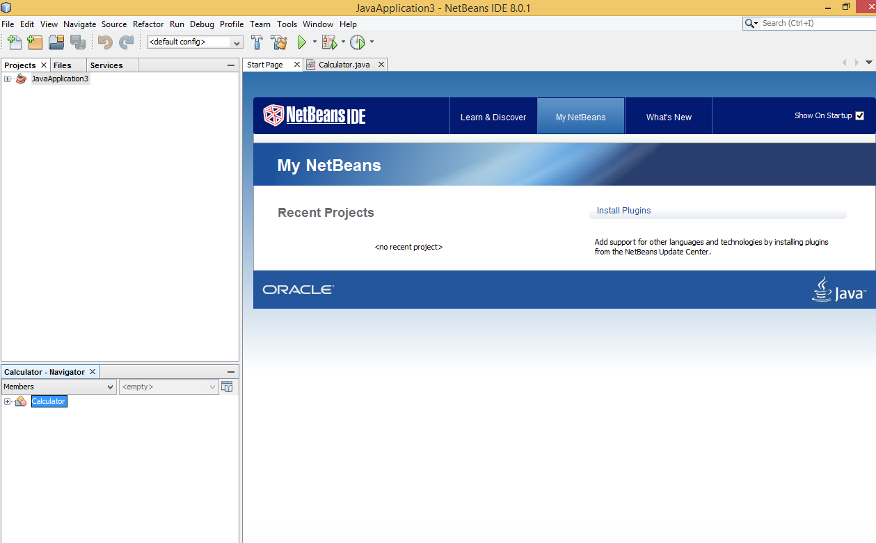
NetBeans IDE’s Interface

 | Task 1.1: Creating a Maven Project in NetBeans IDE

- Eclipse: It is an IDE that contains a workspace and plugins for developing and testing primarily Java applications. It supports other programming languages as well, such as C, C++, COBOL, FORTRAN, JavaScript, Perl, and PHP. Apart from supporting various languages, Eclipse has various other features as well. Some of these features are:
- It is a simple IDE, but mainly plug-in driven integrated development environment. It maximizes the productivity by giving in-built support for code development and maintenance.
- It has in-built compiler and interpreter.
- It also supports various types of application, such as console based, mobile based, and Web based.
- Similar to NetBeans, it is open-source IDE sponsored by IBM, but is quite easier to set up and configure.
- It runs on cross-platform machines including Windows, Mac OS X, GNU/Linux, and Solaris. These machines must have JVM installed on them.
- It has in-built JDBC driver support, which is cumbersome to configure.
- It has an automatic build feature, which automatically compiles the changes in the code.
When you open Eclipse IDE, the interface of Eclipse appears, as shown in the following figure.
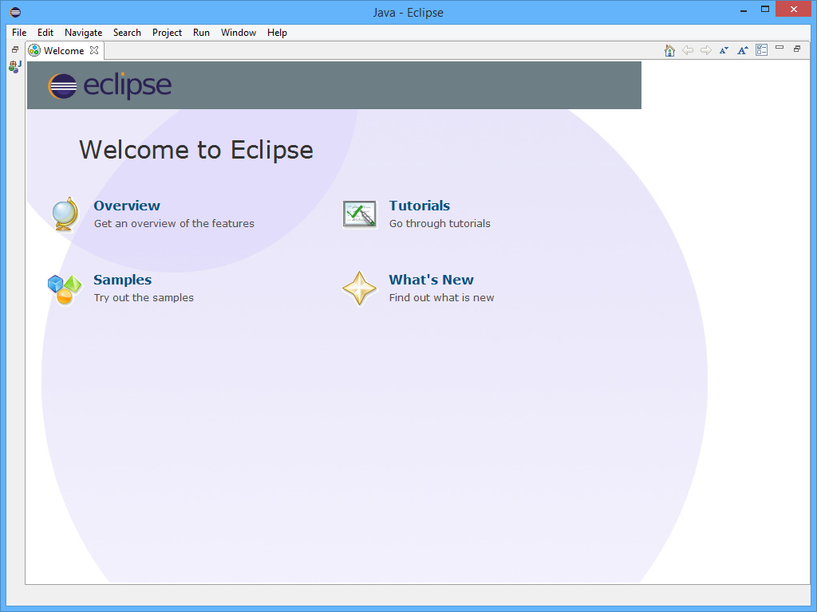
The Eclipse IDE Interface

Identifying JUnit as a Testing Tool
JUnit is an open-source testing framework provided for Java programming language. This framework provides various annotations to test the code and makes the testing process simple and quick. The JUnit framework emphasizes the idea of testing the code before it is coded. It means that first you should design the tests for a code, then write the code, and finally test the code using the designed test. This process simplifies the development and debugging of an application because you test a piece of code as soon as you write it. This helps in quickly identifying and fixing the errors, thereby making the code bug-free and reliable.
The JUnit framework has the following features:
- To test a unit of code, JUnit provides the unit test case that verifies the output of the code under test in accordance with the input for the code. It means a unit test case can be considered as a simple method that checks the output of a function of a class for a particular input for the function.
- You can automatically execute JUnit test cases individually and then obtain a summarized report in the end.
- It shows a progress bar that signifies the success or failure of test cases in red or green, respectively. Therefore, you can easily interpret the test results.
- A Java program consists of various methods that are encapsulated within a class to create a collection. Similarly, a JUnit test class consists of various test cases. When you have multiple test classes, you can organize these test classes into a collection known as test suite. A test suite is a class that comprises different test classes that are executed one after the other automatically.
- It allows execution of multiple tests concurrently and, therefore, saves time.
Let us now understand the architecture of the JUnit framework.
The JUnit Framework Architecture
The working of the JUnit framework is a simple process, which is easy to understand. JUnit is primarily designed to perform unit testing. To perform testing, you need to create test cases for the methods that you intend to test. These tests need to be executed for verifying the functionality of the application being tested. Therefore, when you perform unit testing using JUnit, the JUnit framework performs certain tasks. The process used by the JUnit framework to execute a test and display the result constitutes the architecture of JUnit. The JUnit framework has the following architecture.
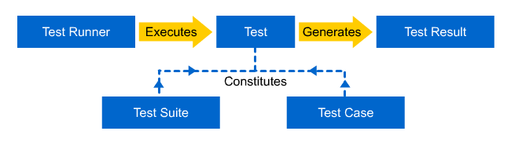
The JUnit Framework Architecture
The architecture of the JUnit framework comprises the following elements:
- Test case: This is the smallest unit of any JUnit test that verifies the functionality of a method being tested.
- Test suite: When you have multiple test classes and you want to automatically execute these classes one after the other, you can create a test suite.
- Test: It is a collection of one or more test cases or test suites that are executed to perform the testing of an application.
- Test runner: When you execute a normal Java program file, the output of the program is displayed to you. However, when you execute a test Java file, test results are displayed to the user in form of red or green bar. This is because the execution process of a test is different from a simple Java file. When you execute a test, the test runner is executed in the background, which displays the result of the test in terms of pass or fail.
- Test result: It refers to the outcome of a test, which is displayed to the user. This test result is collected from the test class.

Just a minute:
Which one of the following options describes a class that comprises different test classes that are executed one after the other automatically?
- Test result
- Test runner
- Test suite
- Test case
Answer:
3. Test suite

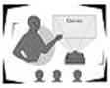 | Activity 1.1: Creating Test Scenarios

Activity 1.2: Executing Test Cases in JUnit

Practice Questions
- Which one of the following phases of STLC includes setting up the necessary tools and infrastructure required for convenient and smooth execution of the tests?
- Test environment setup
- Requirement analysis
- Test planning
- Test execution
- Which one of the following phases of STLC involves fixing of defects till the time all the results are successful?
- Requirement analysis
- Test closure
- Test execution
- Test case development
- Which one of the following types of testing ensures that the individual units are reliable and error-free?
- Integration testing
- System testing
- Acceptance testing
- Unit testing
- Which one of the following elements of JUnit architecture is the smallest unit of any JUnit test that verifies the functionality of a method being tested?
- Test case
- Test suite
- Test
- Test runner
- Which one of the following elements of JUnit architecture is executed in the background to execute a test that displays the result of the test in terms of pass or fail?
- Test result
- Test runner
- Test
- Test suite

Summary
In this chapter, you learned that:
- Software testing plays a vital role in the development of defect-free software.
- STLC is a systematic and progressive approach used for testing software to enhance its quality.
- STLC consists of the following six phases:
  - Requirement analysis
  - Test planning
  - Test environment setup
  - Test case development
  - Test execution
  - Test closure
- The black box testing strategy tests the software for its overall functionality and does not test each statement and branches given in the code.
- In white box testing strategy, you need to understand the code and then test every statement and condition given in the code.
- The testing of small pieces of code, known as units, is known as unit testing.
- The unit testing should be done to ensure that the smallest unit of the code is bug-free and reusable.
- JUnit is an open-source testing framework provided for Java programming language.
- The architecture of the JUnit framework comprises the following elements:
- Test case
- Test suite
- Test
- Test runner
- Test result

